Links for SPSS

Overview:

<https://www.spss-tutorials.com/simple-overview-statistical-comparison-tests/>

Mann-Whitney Test

The Mann-Whitney U test is used to compare whether there is a difference in the dependent variable for two independent groups. It compares whether the distribution of the dependent variable is the same for the two groups and therefore from the same population. The test ranks all of the dependent values i.e. lowest value gets a score of one and then uses the sum of the ranks for each group in the calculation of the test statistic.

Dependent: Numerical/continuous (skewed) or ordinal

Independent: Nominal (binary).

Assumptions The only assumptions for carrying out a Mann-Whitney test are that the two groups must be independent and that the dependent variable is ordinal or numerical (continuous). However, in order to report the difference between groups as medians, the shape of the distributions of the dependent variable by group must be similar. It doesn’t matter if the distributions have a different location on the x-axis, they just have to be a similar shape.

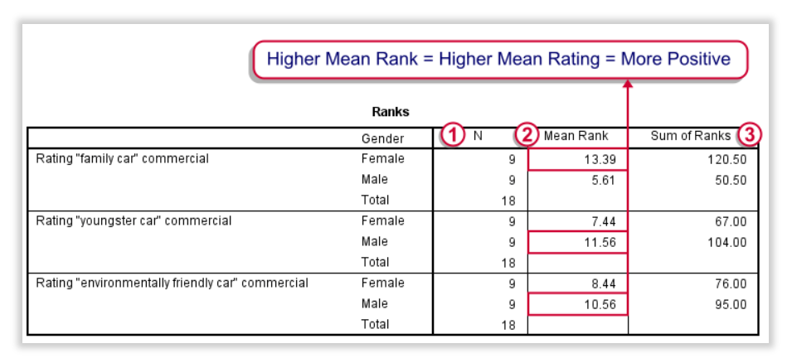

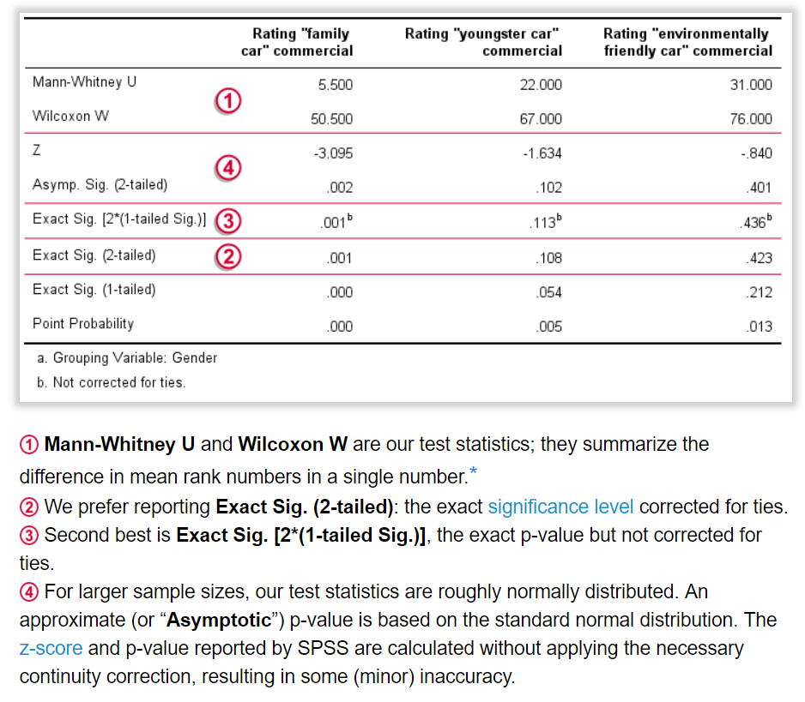

<https://www.spss-tutorials.com/spss-mann-whitney-test-simple-example/>

<https://www.sheffield.ac.uk/polopoly_fs/1.714552!/file/stcp-marshall-MannWhitS.pdf>

# Wilcoxon Signed-Ranks Test

Used when two measurements of the same dependent variable are taken at different time points or under different conditions for each subject and the assumptions of the paired t test have not been met.

Dependent: Continuous (scale) or ordinal

Independent: Time/condition

<https://www.spss-tutorials.com/spss-wilcoxon-signed-ranks-test-simple-example/>

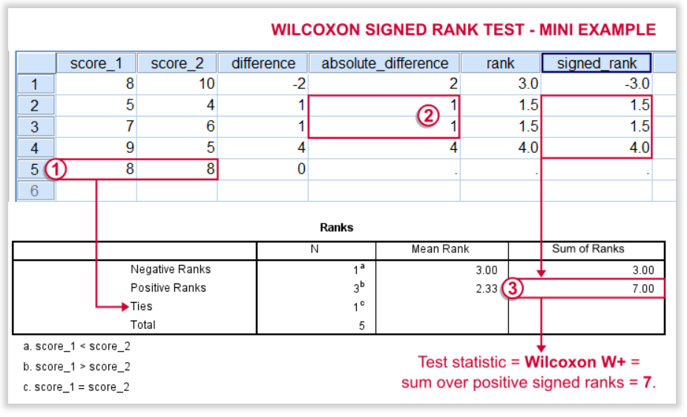

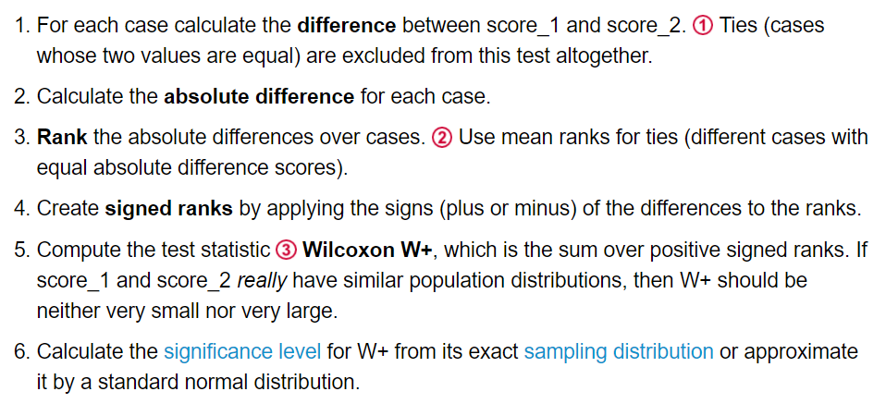

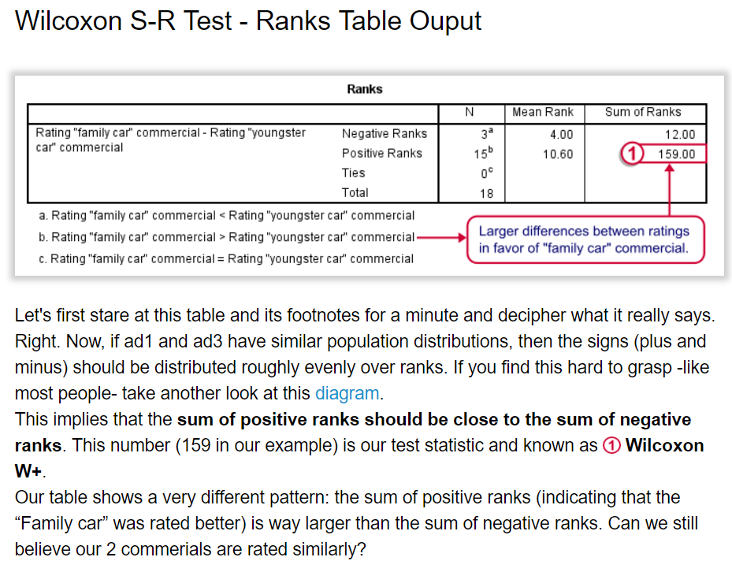

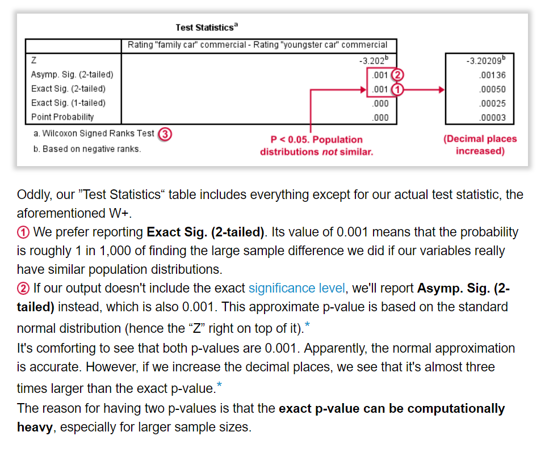

# Kruskal-Wallis Test

(Non-parametric equivalent to ANOVA)

Research question type: Differences between several groups of measurements

Dependent variable: Continuous (scale) but not normally distributed or ordinal

Independent variable: Categorical (Nominal)

Common Applications: Comparing the mean rank of three or more different groups in scientific or medical experiments when the dependent variable ordinal or is not normally distributed. Descriptive statistics: Median for each group and box-plot.

It is important to realize that the Kruskal-Wallis H test is an omnibus test statistic and cannot tell you which specific groups of your independent variable are statistically significantly different from each other; it only tells you that at least two groups were different. Since you may have three, four, five or more groups in your study design, determining which of these groups differ from each other is important. You can do this using a post hoc tes

<https://statistics.laerd.com/spss-tutorials/kruskal-wallis-h-test-using-spss-statistics.php>

Go to the Analyze menu>non Parametric tests>independent samples.

- Objective tabs: choose custom analysis

- Enter the data to compare in the Fields tab

- In the Setting tab, choose Kruskal Wallis, and choose all Pairwise.

Click on run

<https://www.spss-tutorials.com/spss-kruskal-wallis-test-simple-tutorial-with-example/>

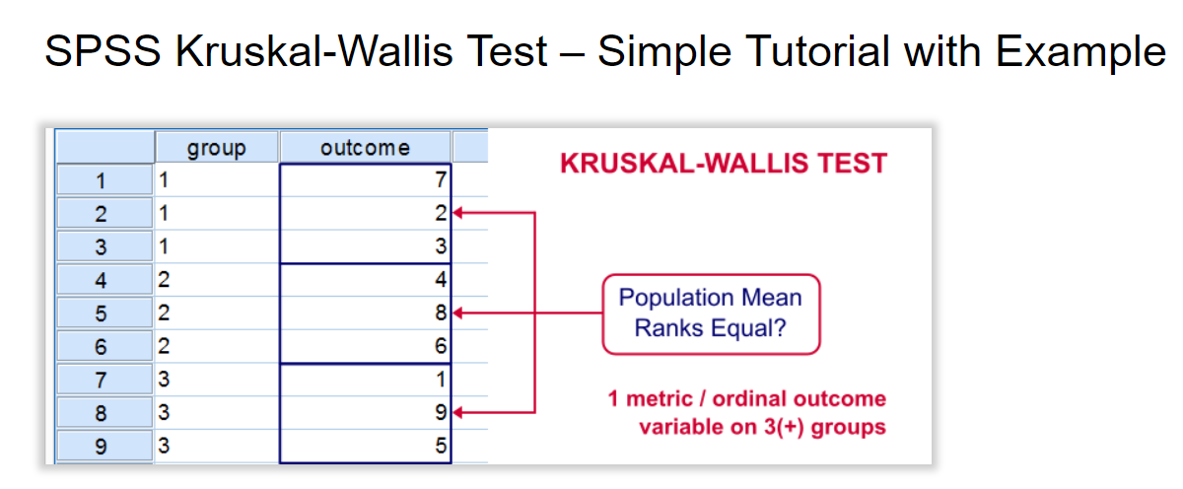

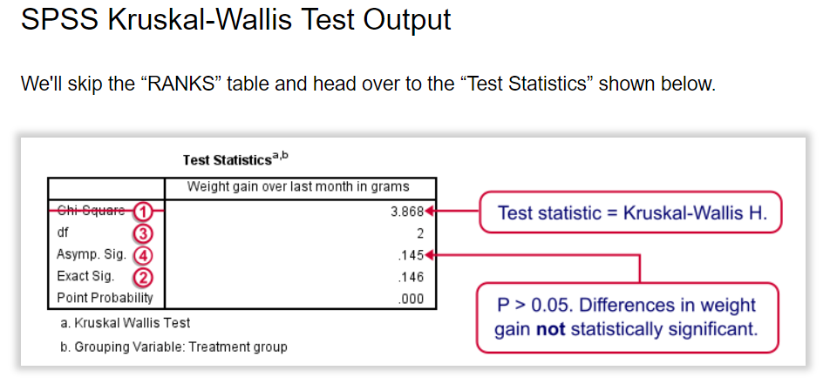

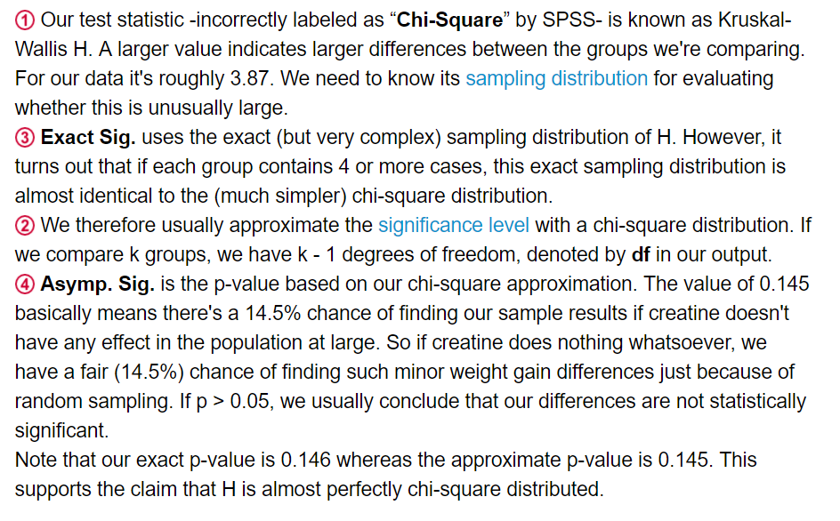

# Friedman Test

The Friedman test is the non-parametric alternative to the [one-way ANOVA with repeated measures](https://statistics.laerd.com/spss-tutorials/one-way-anova-repeated-measures-using-spss-statistics.php). It is used to test for differences between groups when the dependent variable being measured is ordinal. It can also be used for continuous data that has violated the assumptions necessary to run the one-way ANOVA with repeated measures (e.g., data that has marked deviations from normality).

<https://www.spss-tutorials.com/spss-friedman-test-simple-example/>

<https://statistics.laerd.com/spss-tutorials/friedman-test-using-spss-statistics.php>

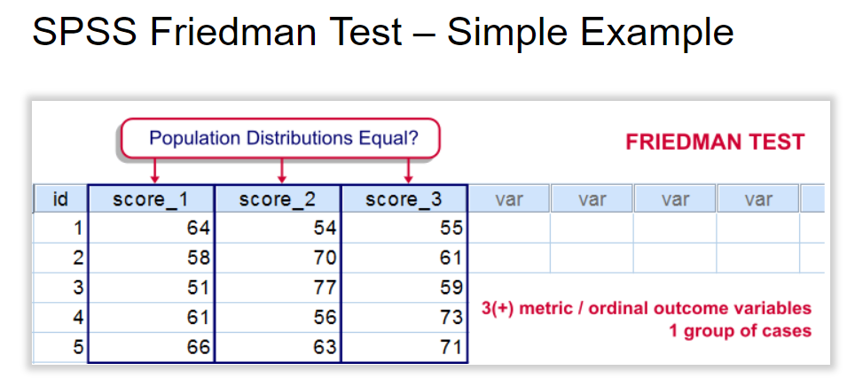

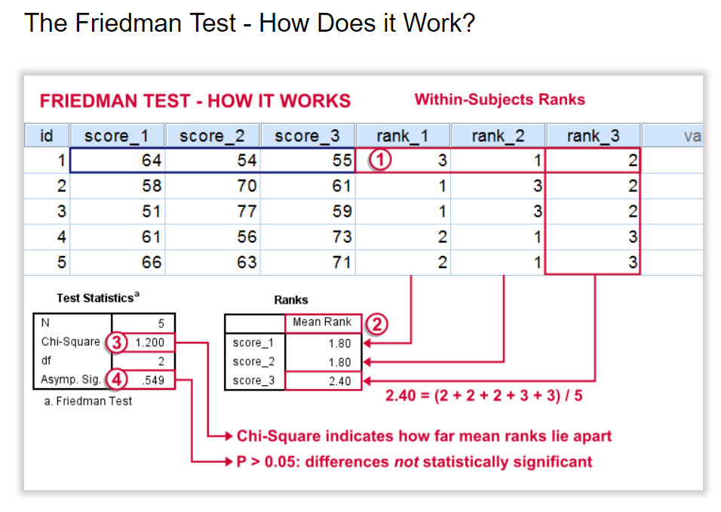

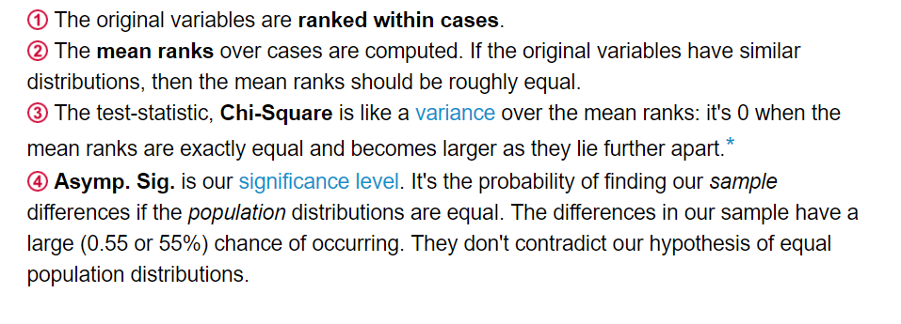

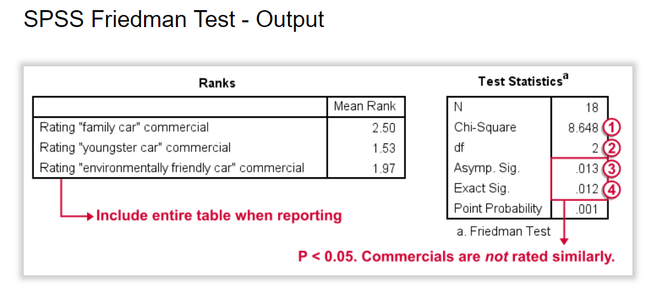

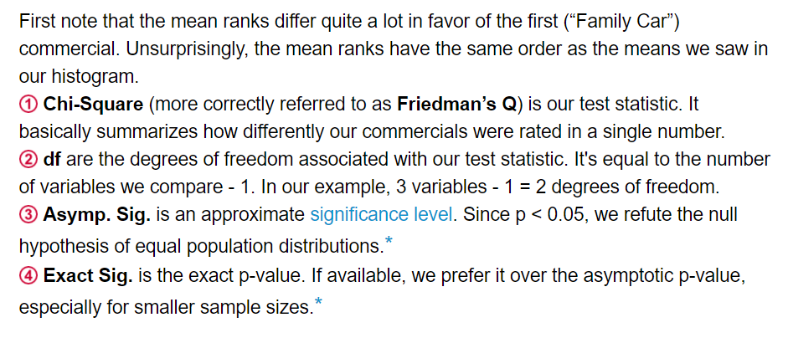

a **type I error** is the incorrect rejection of a true [null hypothesis](https://en.wikipedia.org/wiki/Null_hypothesis) (also known as a "false positive" finding), while a **type II error** is incorrectly retaining a false null hypothesis (also known as a "false negative" finding).[[1]](https://en.wikipedia.org/wiki/Type_I_and_type_II_errors#cite_note-1) More simply stated, a type I error is to falsely infer the existence of something that is not there, In terms of [folk tales](https://en.wikipedia.org/wiki/Old_wives%27_tale), an investigator may see the wolf when there is none ("raising a false alarm"). Where the null hypothesis, *H*0, is: no wolf.

while a type II error is to falsely infer the absence of something that is. In terms of folk tales, an investigator may fail to see the wolf when it is present ("failing to raise an alarm"). Again, *H*0: no wolf.

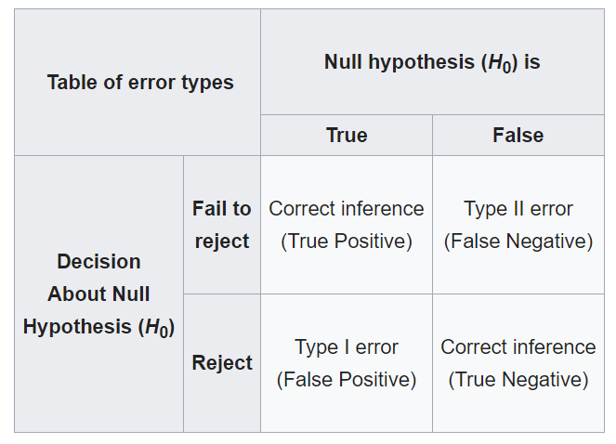

# ANOVA

The one-way analysis of variance (ANOVA) is used to determine whether there are any statistically significant differences between the means of two or more independent (unrelated) groups (although you tend to only see it used when there are a minimum of three, rather than two groups). For example, you could use a one-way ANOVA to understand whether exam performance differed based on test anxiety levels amongst students, dividing students into three independent groups (e.g., low, medium and high-stressed students). Also, it is important to realize that the one-way ANOVA is an omnibus test statistic and cannot tell you which specific groups were statistically significantly different from each other; it only tells you that at least two groups were different. Since you may have three, four, five or more groups in your study design, determining which of these groups differ from each other is important. You can do this using a post hoc test (N.B., we discuss post hoc tests later in this guide).

<https://www.spss-tutorials.com/anova-what-is-it/>

<https://statistics.laerd.com/spss-tutorials/one-way-anova-using-spss-statistics.php>

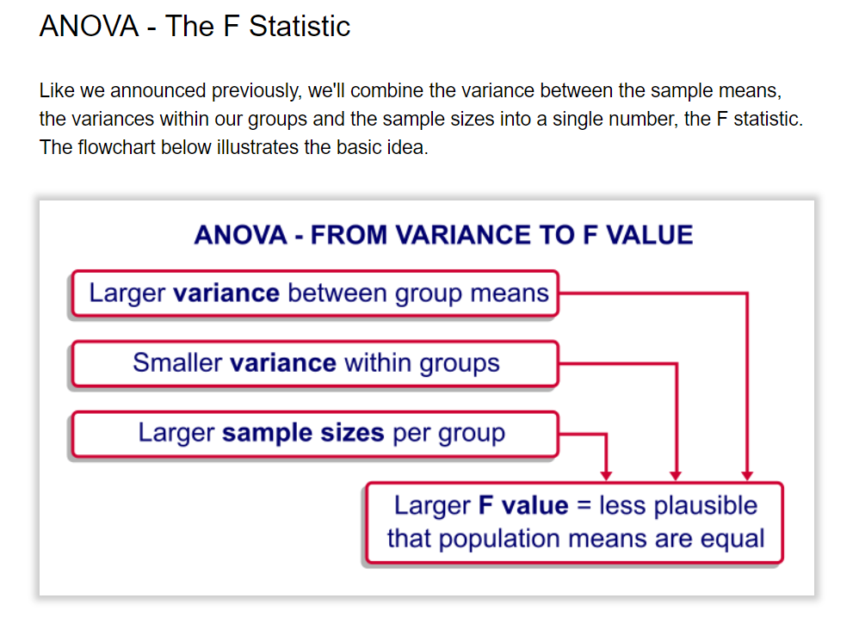

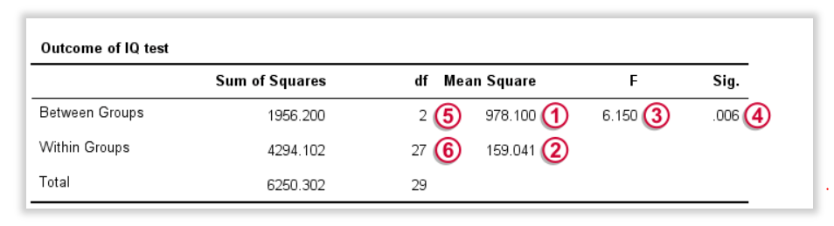

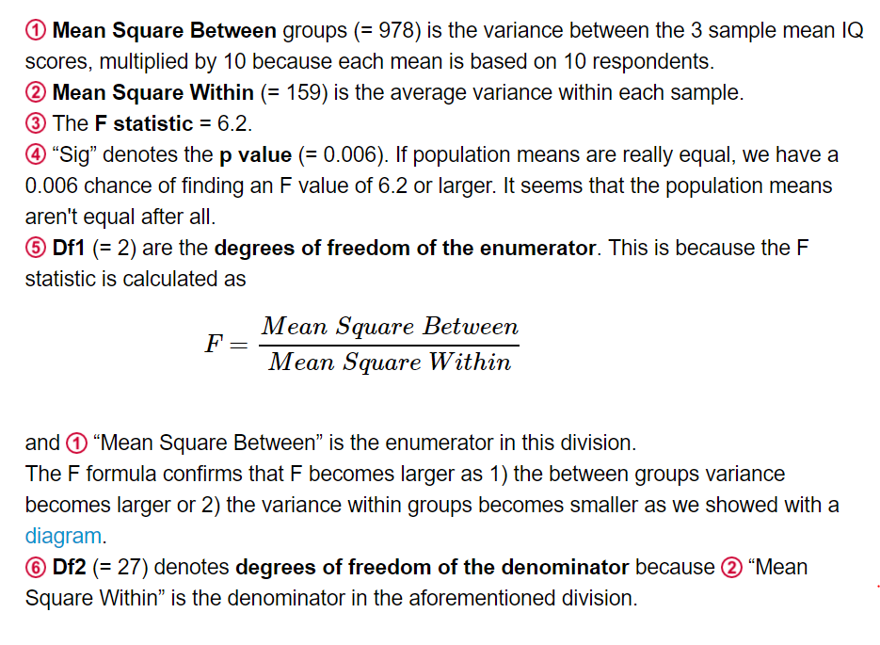

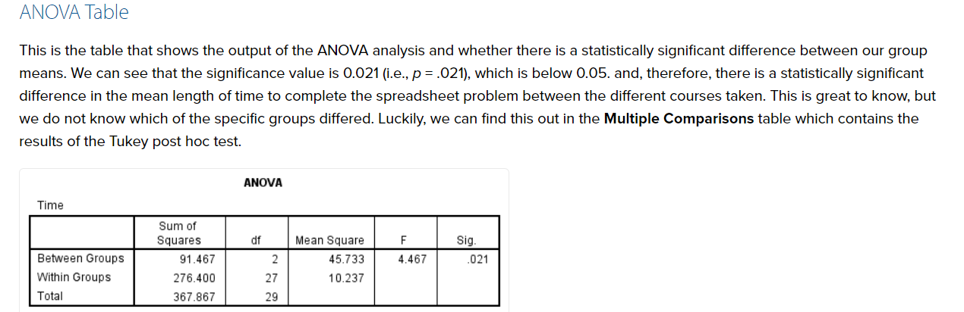

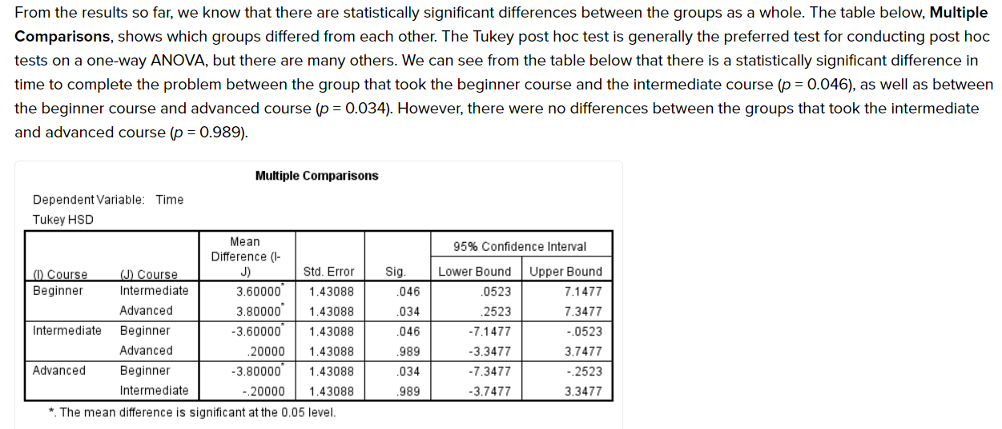

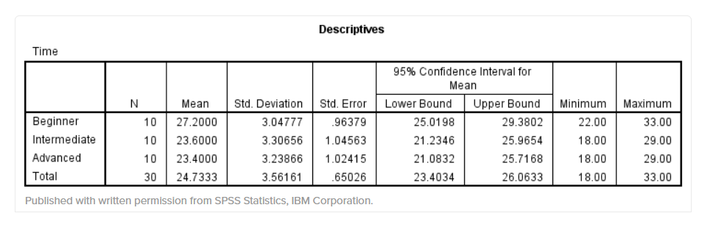

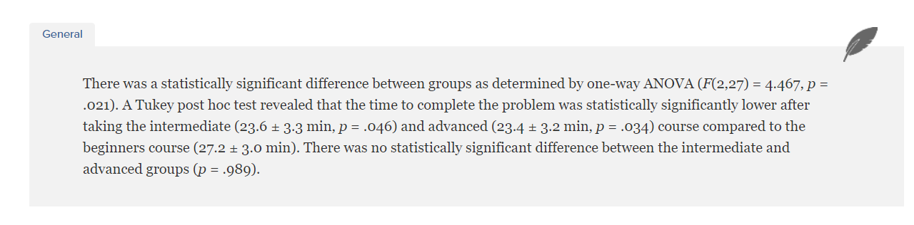

(Partial) Eta Squared ( <https://www.spss-tutorials.com/spss-partial-eta-squared/> )

partial η2 is the **proportion of variance accounted for** by some effect. More precisely,

partialη2= SSeffectSSeffect+SSerrorpartialη2=SSeffectSSeffect+SSerror

where SS is short for “sums of squares”, the total amount of dispersion in our dependent variable. This means that partial η2 is the variance attributable to an effect divided by the variance that *could have been* attributable to this effect.

Levene’s Test

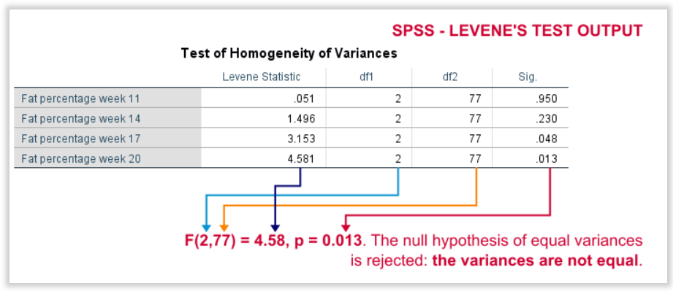

# Factorial ANOVA

<https://www.statisticssolutions.com/conduct-interpret-factorial-anova/>

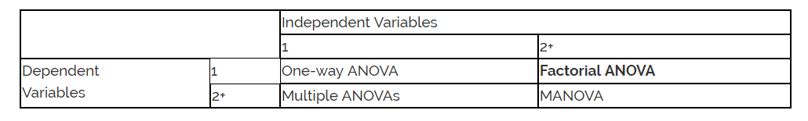

<https://www.youtube.com/watch?v=mp5lRMiqpOU> (difference between anova, factors and Manova)

The two-way ANOVA compares the mean differences between groups that have been split on two independent variables (called factors). The primary purpose of a two-way ANOVA is to understand if there is an interaction between the two independent variables on the dependent variable.

<https://statistics.laerd.com/spss-tutorials/two-way-anova-using-spss-statistics.php>

<https://www.youtube.com/watch?v=lZFmFuZGQTk>

<https://www.youtube.com/watch?v=6Hmauags3VA>



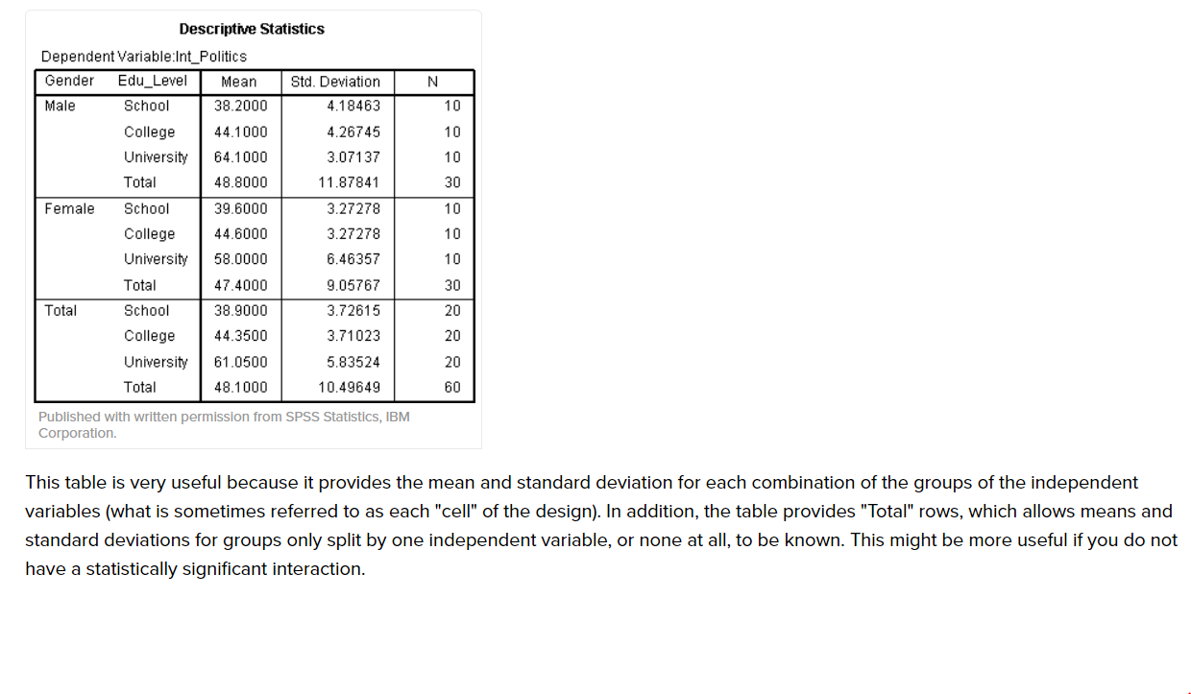

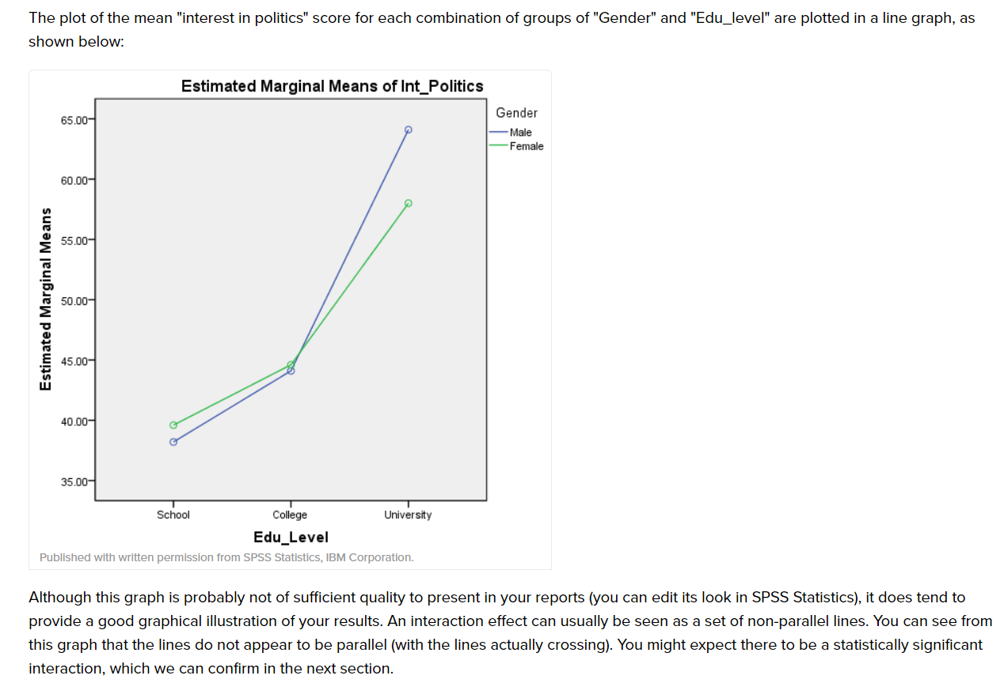

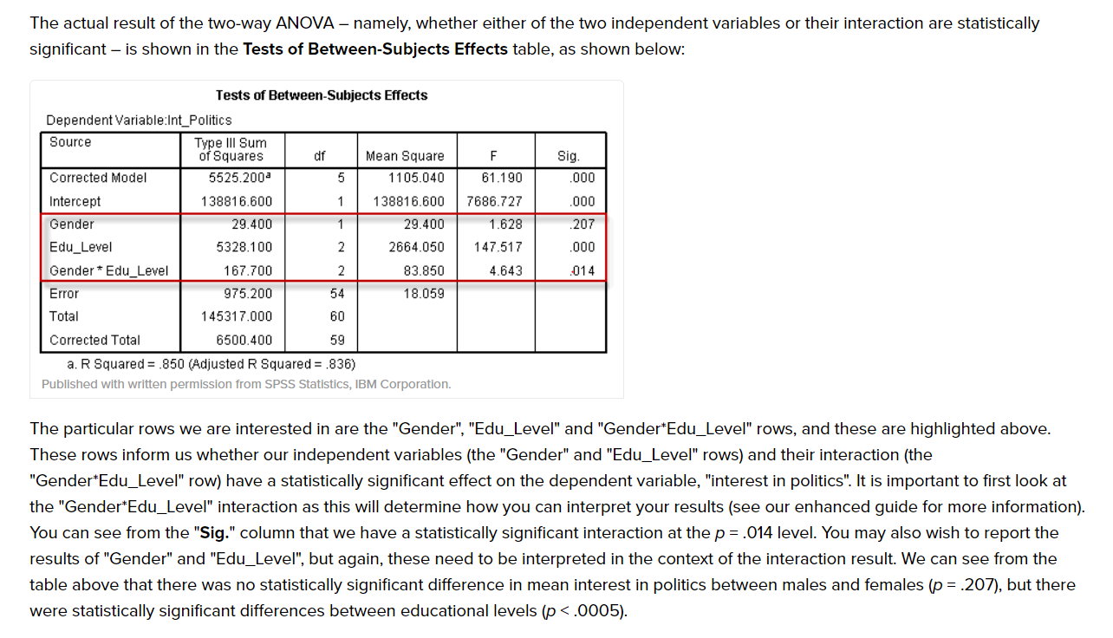

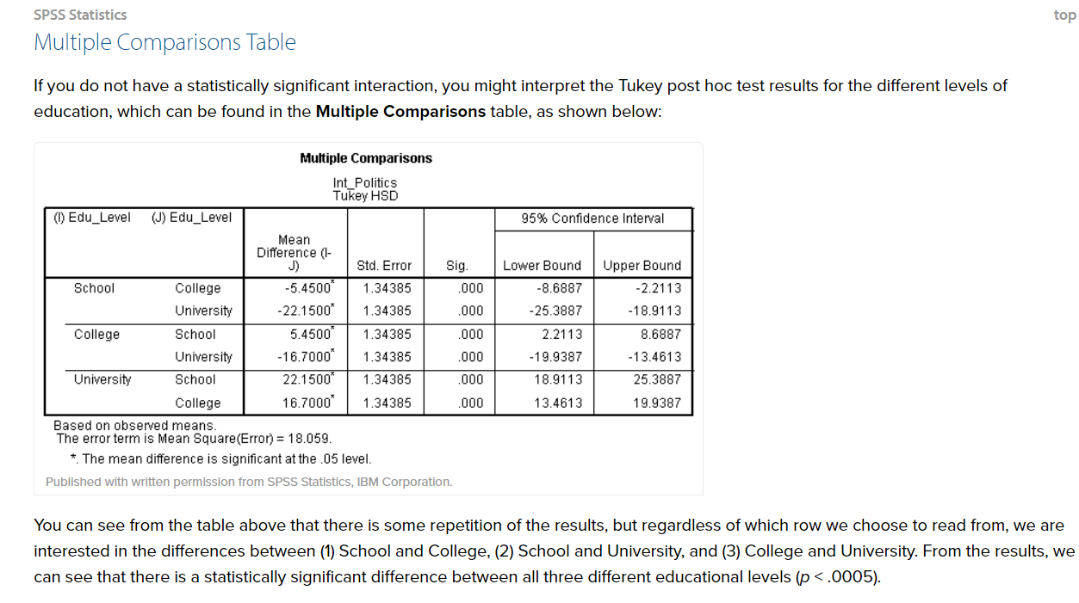

# Test of Normality

<https://statistics.laerd.com/spss-tutorials/testing-for-normality-using-spss-statistics.php>

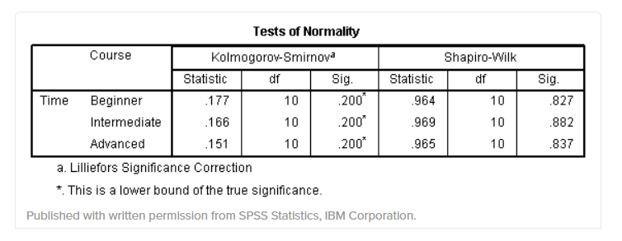

 If the **Sig.** value of the Shapiro-Wilk Test is greater than 0.05, the data is normal. If it is below 0.05, the data significantly deviate from a normal distribution.

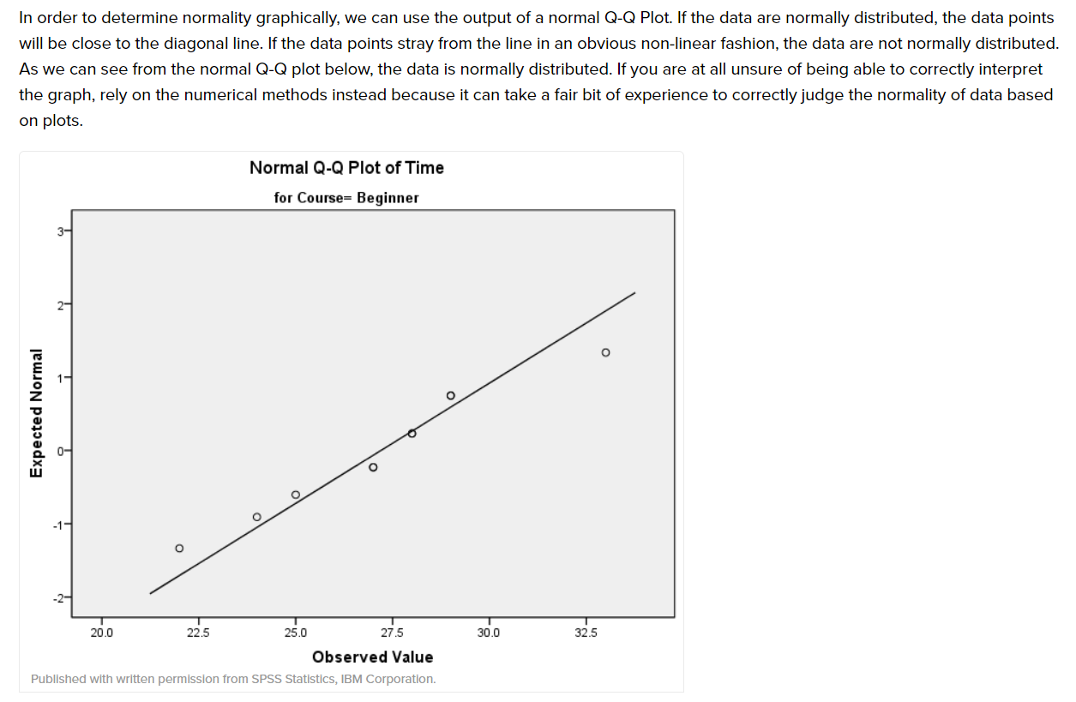

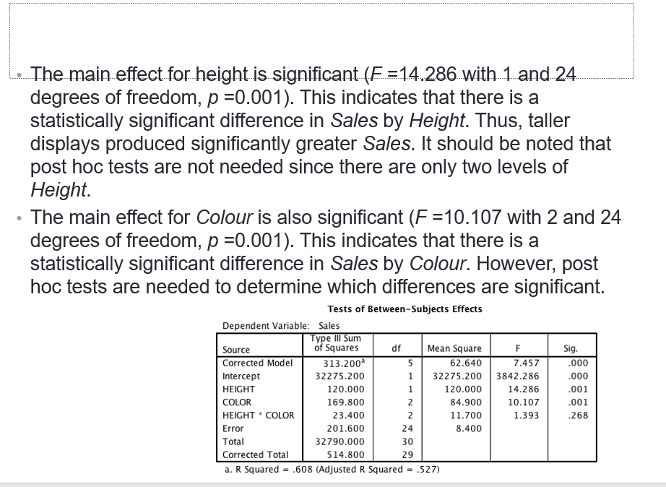

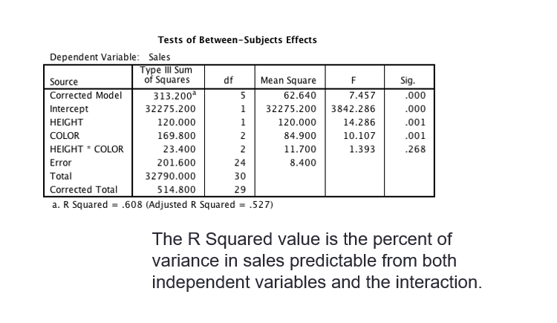

# Manova

<https://www.youtube.com/watch?v=m0zV_wFGA1I>

<https://statistics.laerd.com/spss-tutorials/one-way-manova-using-spss-statistics.php>

The one-way multivariate analysis of variance (one-way MANOVA) is used to determine whether there are any differences between independent groups on more than one continuous dependent variable. In this regard, it differs from a [one-way ANOVA](https://statistics.laerd.com/spss-tutorials/one-way-anova-using-spss-statistics.php), which only measures one dependent variable.

<http://health.uottawa.ca/biomech/courses/apa6101/How%20to%20perform%20a%20MANOVA%20in%20SPSS.pdf>

<https://statistics.laerd.com/spss-tutorials/one-way-manova-using-spss-statistics-2.php>

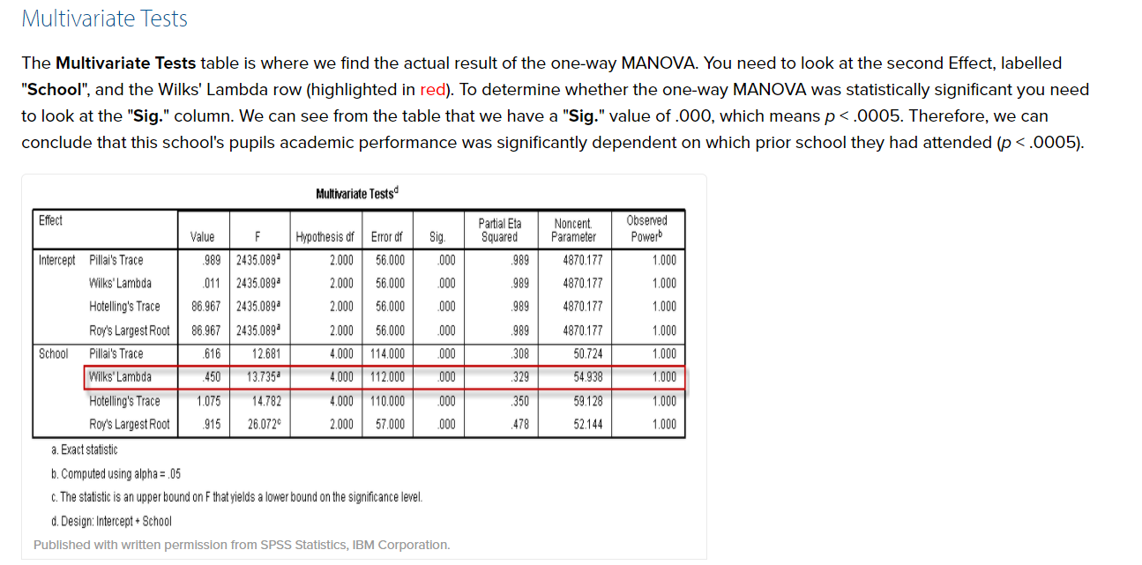

# Correlation

<https://libguides.library.kent.edu/SPSS/PearsonCorr>

<https://www.spss-tutorials.com/spss-correlation-analysis/>

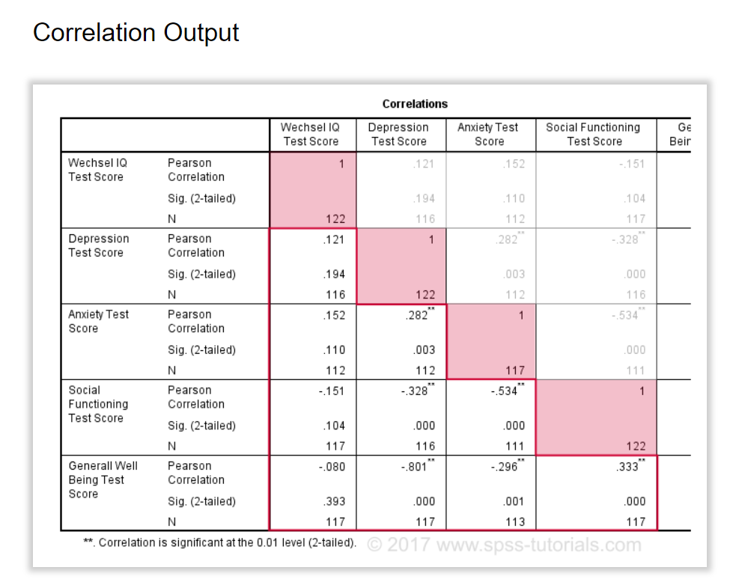

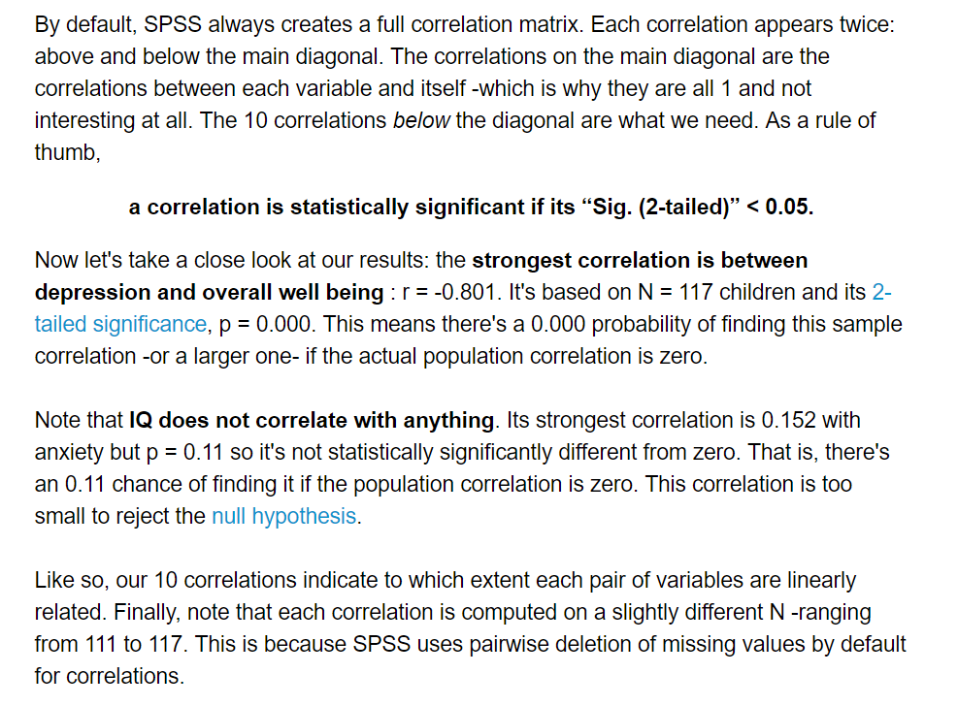

# Partial Correlation

<https://statistics.laerd.com/spss-tutorials/partial-correlation-using-spss-statistics.php>

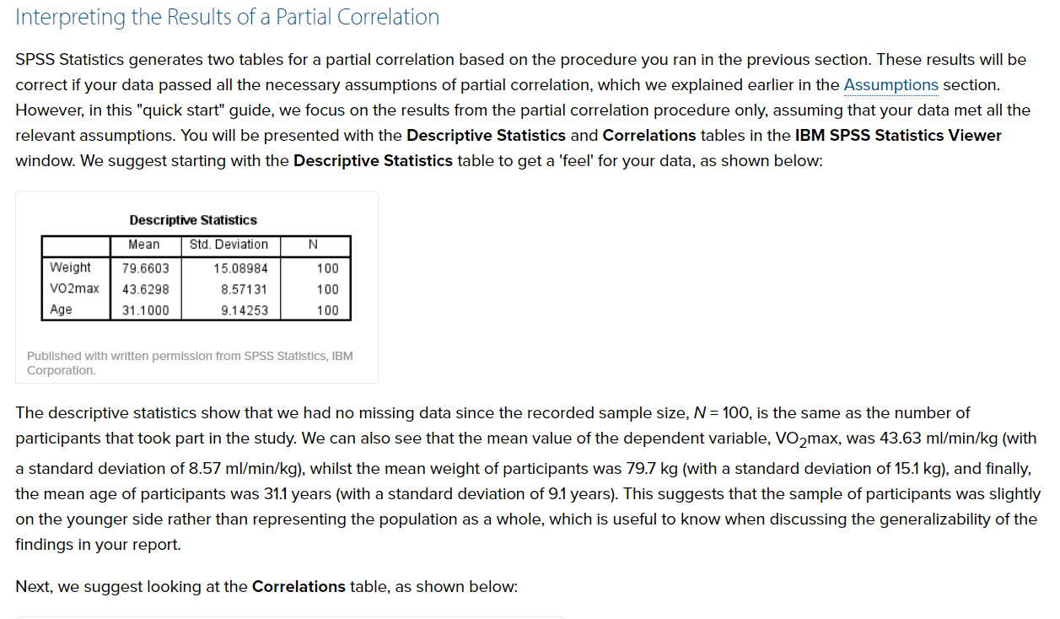

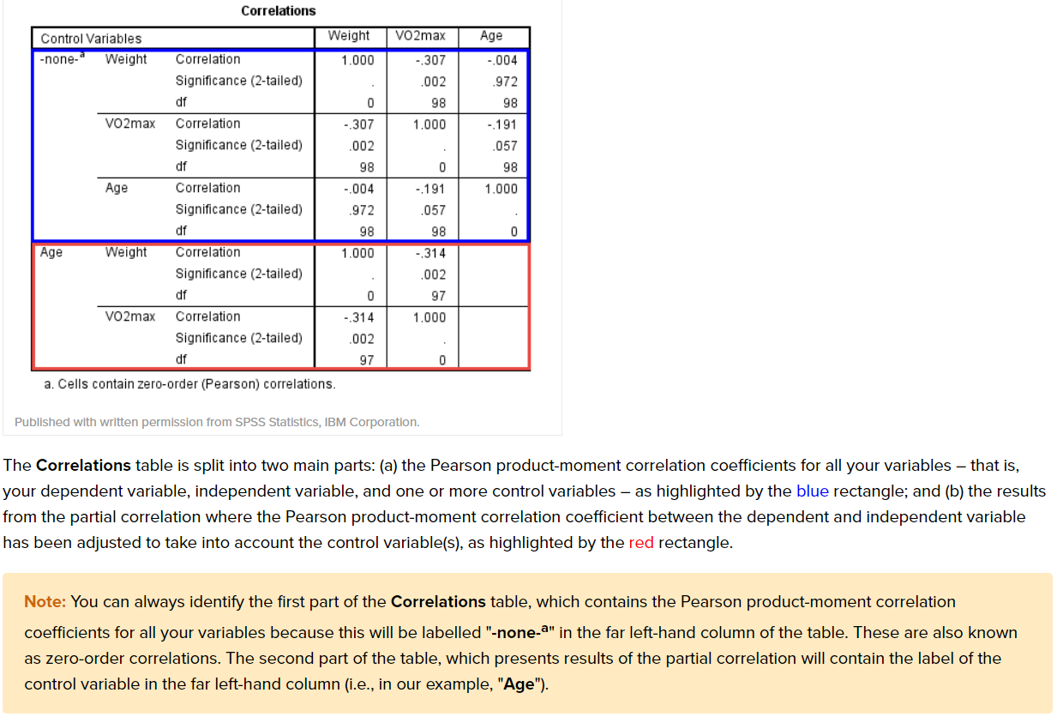

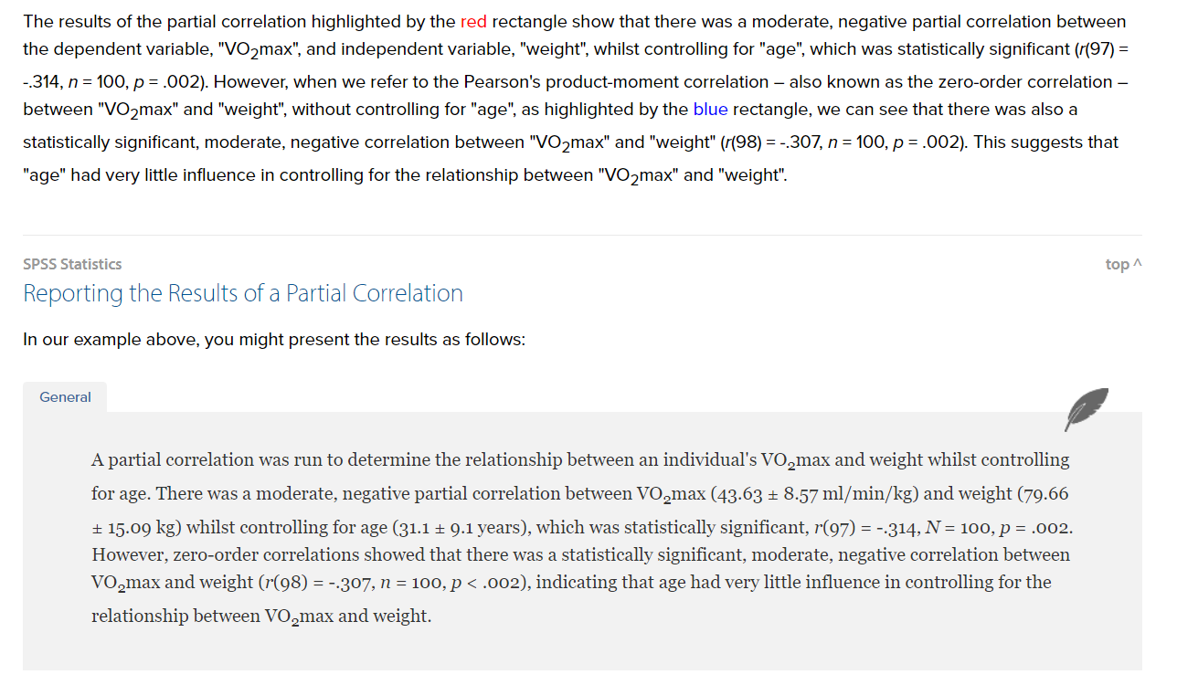

# Homoscedasticity

<http://www.statisticssolutions.com/homoscedasticity/>

# Regression

<http://www.statisticssolutions.com/regression-analysis/>

<http://core.ecu.edu/psyc/wuenschk/SPSS/CorrRegr-SPSS.pdf>

# Multiple Regression

<http://essedunet.nsd.uib.no/cms/topics/regression/6/all.html>

<https://www.statisticssolutions.com/the-multiple-linear-regression-analysis-in-spss/>

<https://stats.idre.ucla.edu/spss/output/regression-analysis/>

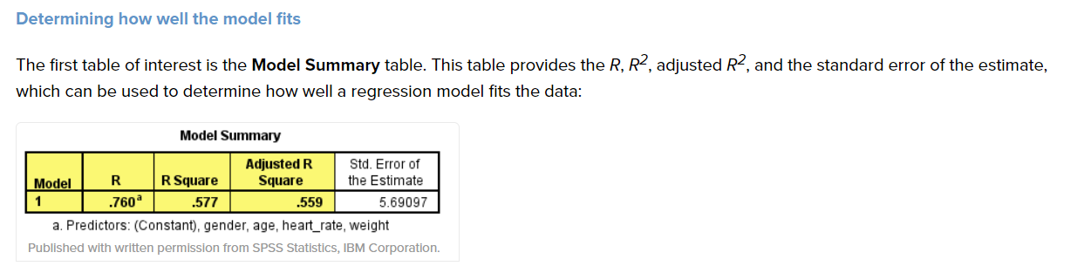

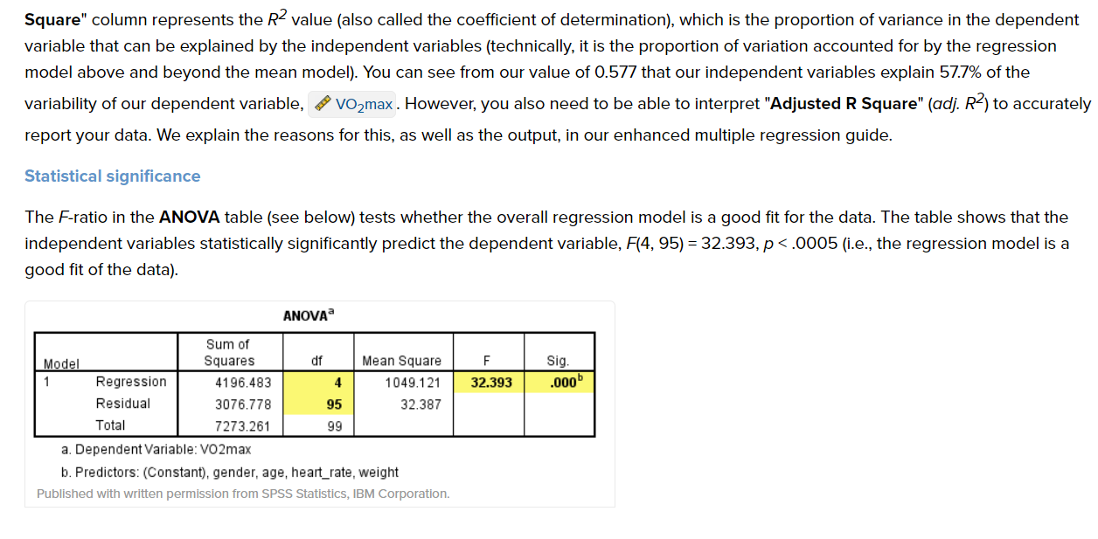

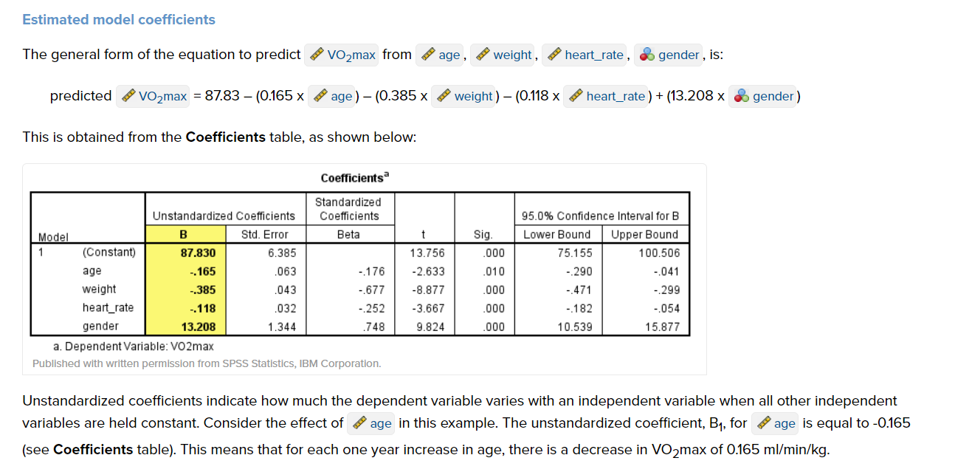

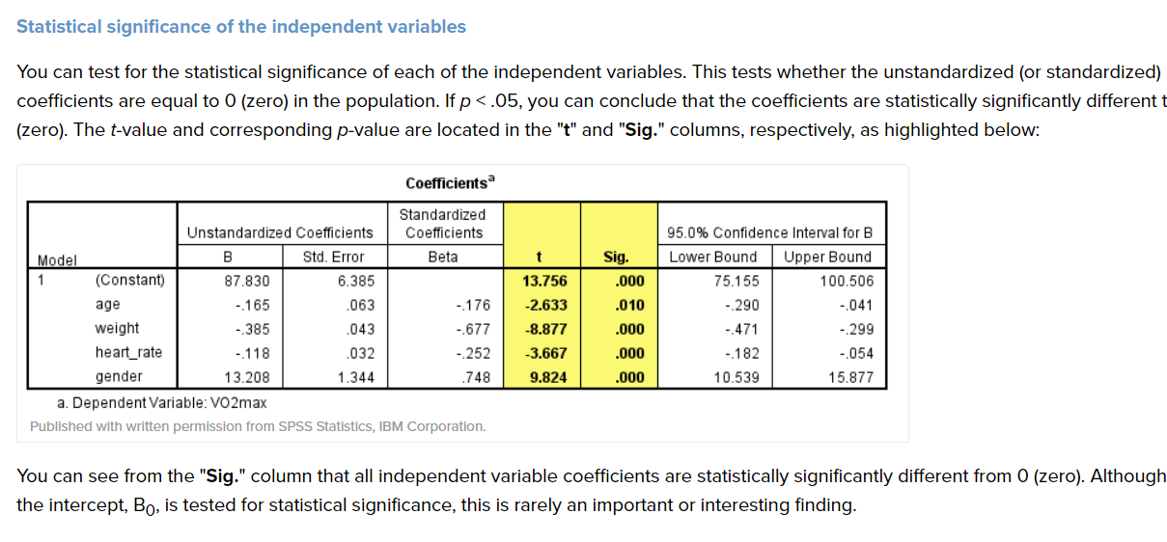

# Logistic Regression

<https://stats.idre.ucla.edu/spss/output/logistic-regression/>

<https://statistics.laerd.com/spss-tutorials/binomial-logistic-regression-using-spss-statistics.php>

<http://core.ecu.edu/psyc/wuenschk/MV/Multreg/Logistic-SPSS.PDF>

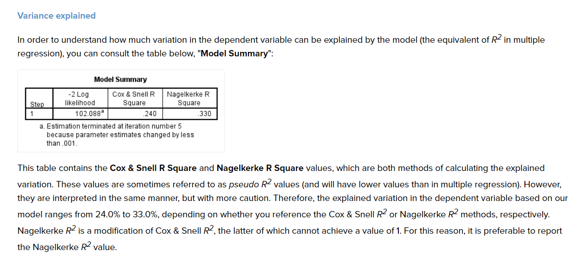

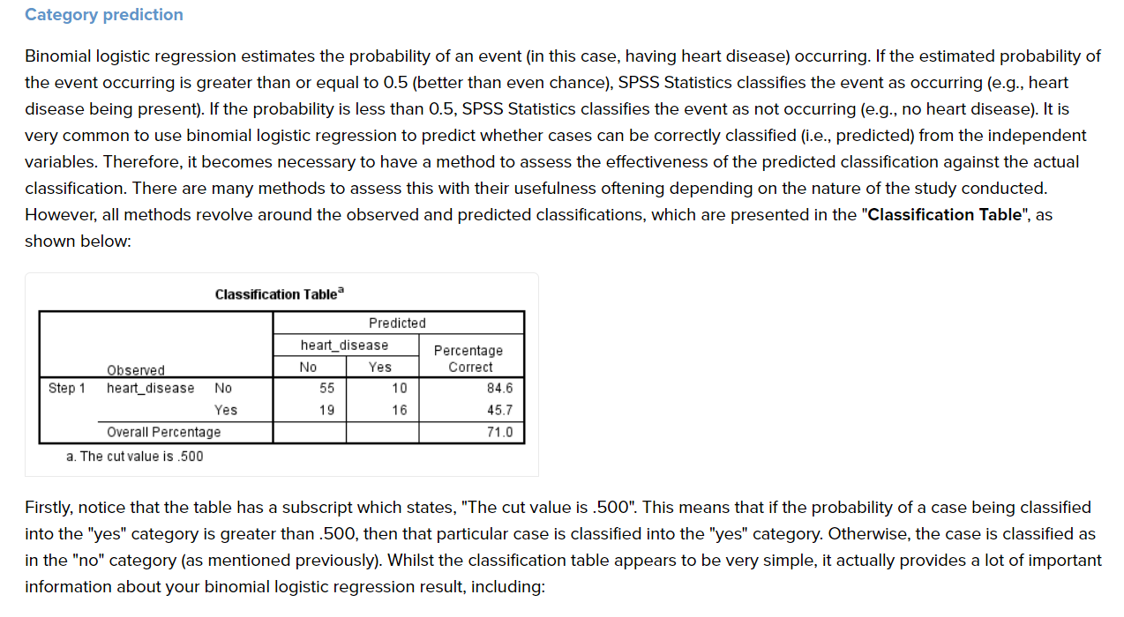

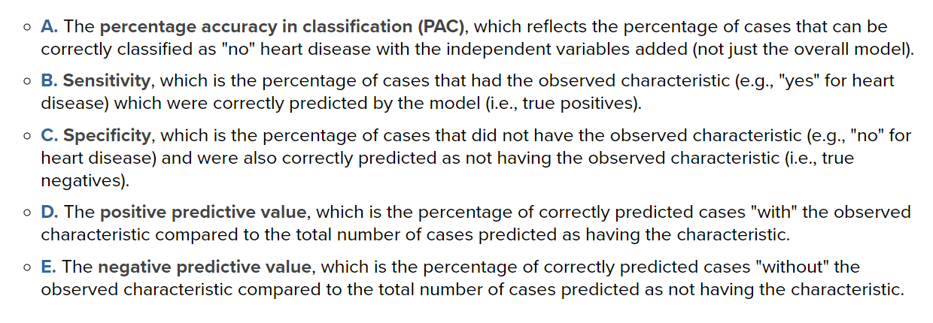

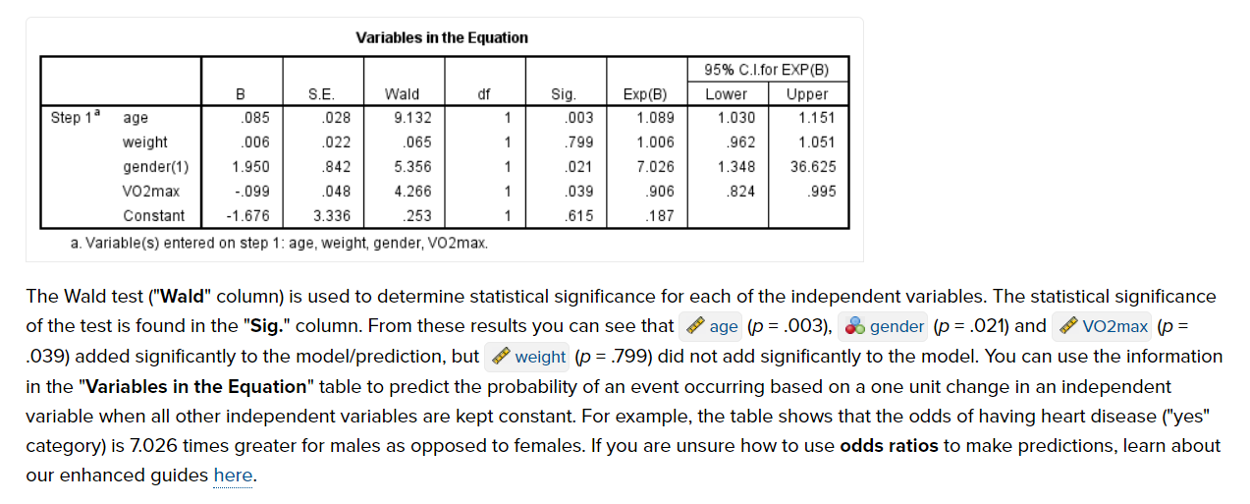

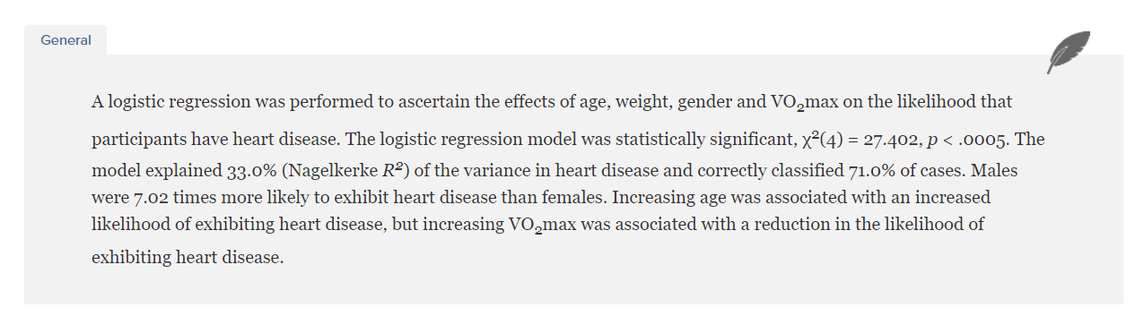

Let’s begin with probability. Probabilities range between 0 and 1. Let’s say that the probability of success is .8, thus

p = .8

Then the probability of failure is

q = 1 – p = .2

Odds are determined from probabilities and range between 0 and infinity. Odds are defined as the ratio of the probability of success and the probability of failure. The odds of success are

odds(success) = p/(1-p) or p/q = .8/.2 = 4,

that is, the odds of success are 4 to 1. The odds of failure would be

odds(failure) = q/p = .2/.8 = .25.

This looks a little strange but it is really saying that the odds of failure are 1 to 4. The odds of success and the odds of failure are just reciprocals of one another, i.e., 1/4 = .25 and 1/.25 = 4. Next, we will add another variable to the equation so that we can compute an odds ratio.

Another example

This example is adapted from Pedhazur (1997). Suppose that seven out of 10 males are admitted to an engineering school while three of 10 females are admitted. The probabilities for admitting a male are,

p = 7/10 = .7 q = 1 – .7 = .3

If you are male, the probability of being admitted is 0.7 and the probability of not being admitted is 0.3.

Here are the same probabilities for females,

p = 3/10 = .3 q = 1 – .3 = .7

If you are female it is just the opposite, the probability of being admitted is 0.3 and the probability of not being admitted is 0.7.

Now we can use the probabilities to compute the odds of admission for both males and females,

odds(male) = .7/.3 = 2.33333 odds(female) = .3/.7 = .42857

Next, we compute the odds ratio for admission,

OR = 2.3333/.42857 = 5.44

Thus, for a male, the odds of being admitted are 5.44 times larger than the odds for a female being admitted.